

Practices for Secure Software Report

Table of Contents
Document Revision History 3
Client 3
Instructions 3
Developer 4
1. Algorithm Cipher 4
2. Certificate Generation 4
3. Deploy Cipher 4
4. Secure Communications 4
5. Secondary Testing 4
6. Functional Testing 4
7. Summary 4
8. Industry Standard Best Practices 4

Document Revision History

Version | Date | Author | Comments
1.0 | 02/24/2024 | Tyler Lever

Client



Developer
Tyler Lever

Algorithm Cipher

AES is considered the industry standard for encryption and is widely adopted algorithm. The biggest vulnerability with AES is key handling. AES is a symmetric encryption algorithm, which means the same key is used for encryption and decryption. An asymmetric algorithm uses a public key to encrypt data and a private key to decrypt. Asymmetric could be seen as a little more secure, but is slower. Because AES is a symmetric algorithm, key handling is the biggest vulnerability and Artemis should implement best practices.
I also recommend Artemis Financial use a hash function to verify data being sent to and from Artemis. A hash function takes inputs information and outputs a unique code. If the information is intercepted and tampered, the code would change. By comparing the code of the received data matches the code of the sent data, we can be confident the data was not changed. SHA-256 is, again, considered the standard for hash functions.

Certificate Generation
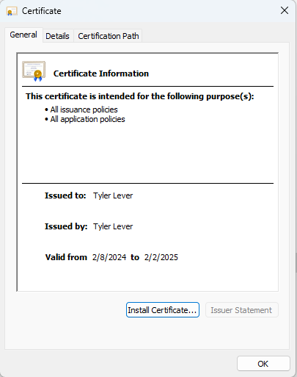

Deploy Cipher
Insert a screenshot below of the checksum verification.

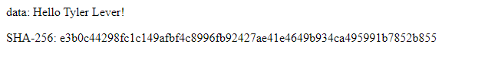

Secure Communications

Insert a screenshot below of the web browser that shows a secure webpage.
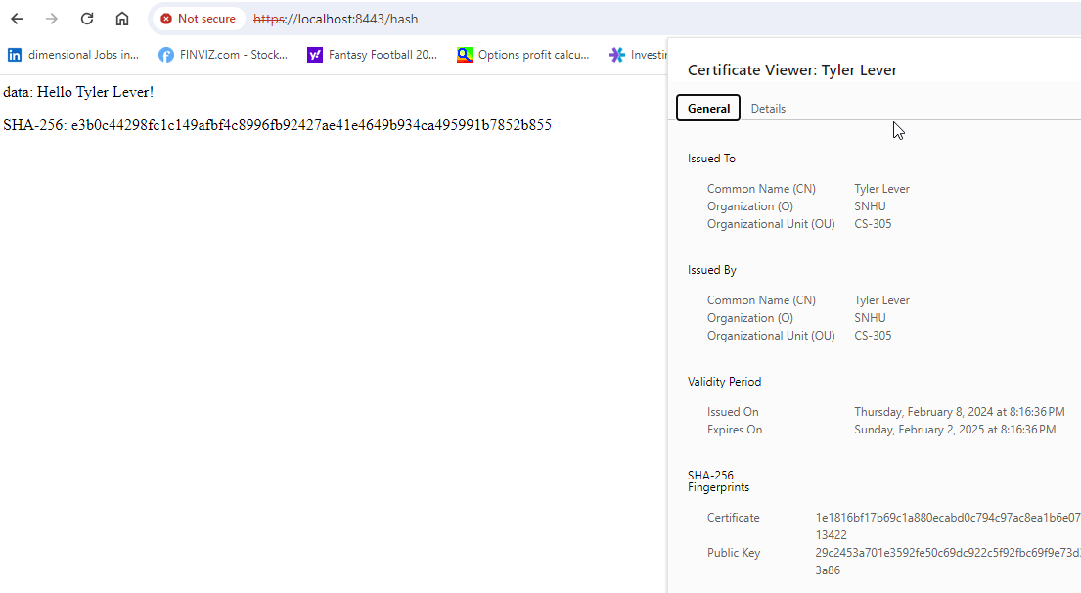
I tried to get Chrome to trust my self-signed cert, even importing my certificate into the Trusted Root Certificate Authorities tab in the security settings. It still doesn’t trust it.

Secondary Testing
Insert screenshots below of the refactored code executed without errors and the dependency-check report.

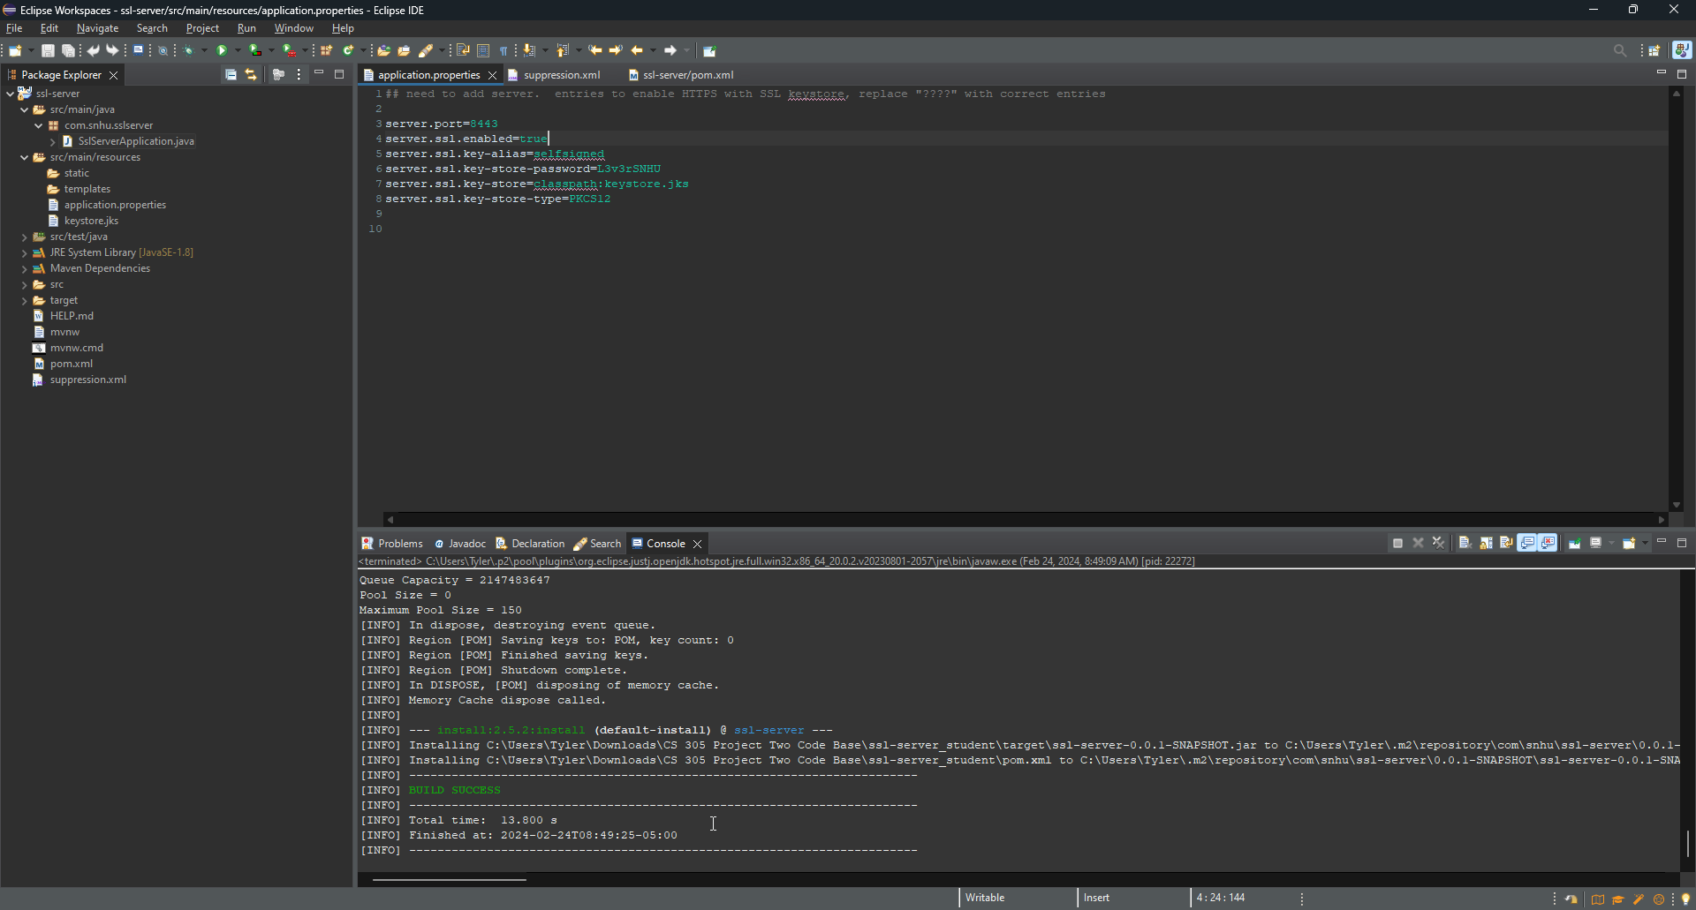
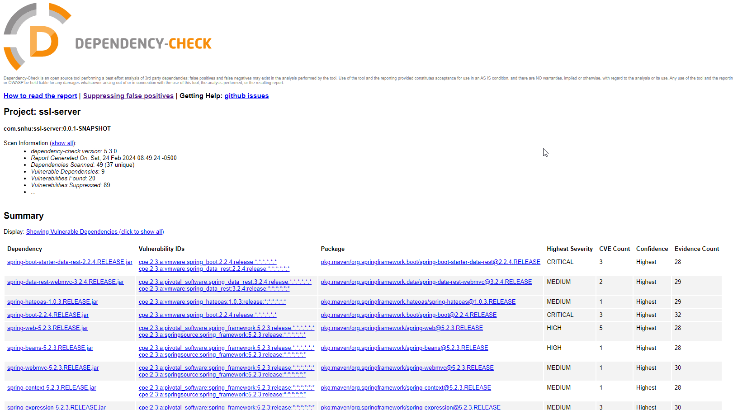

Functional Testing
Insert a screenshot below of the refactored code executed without errors.
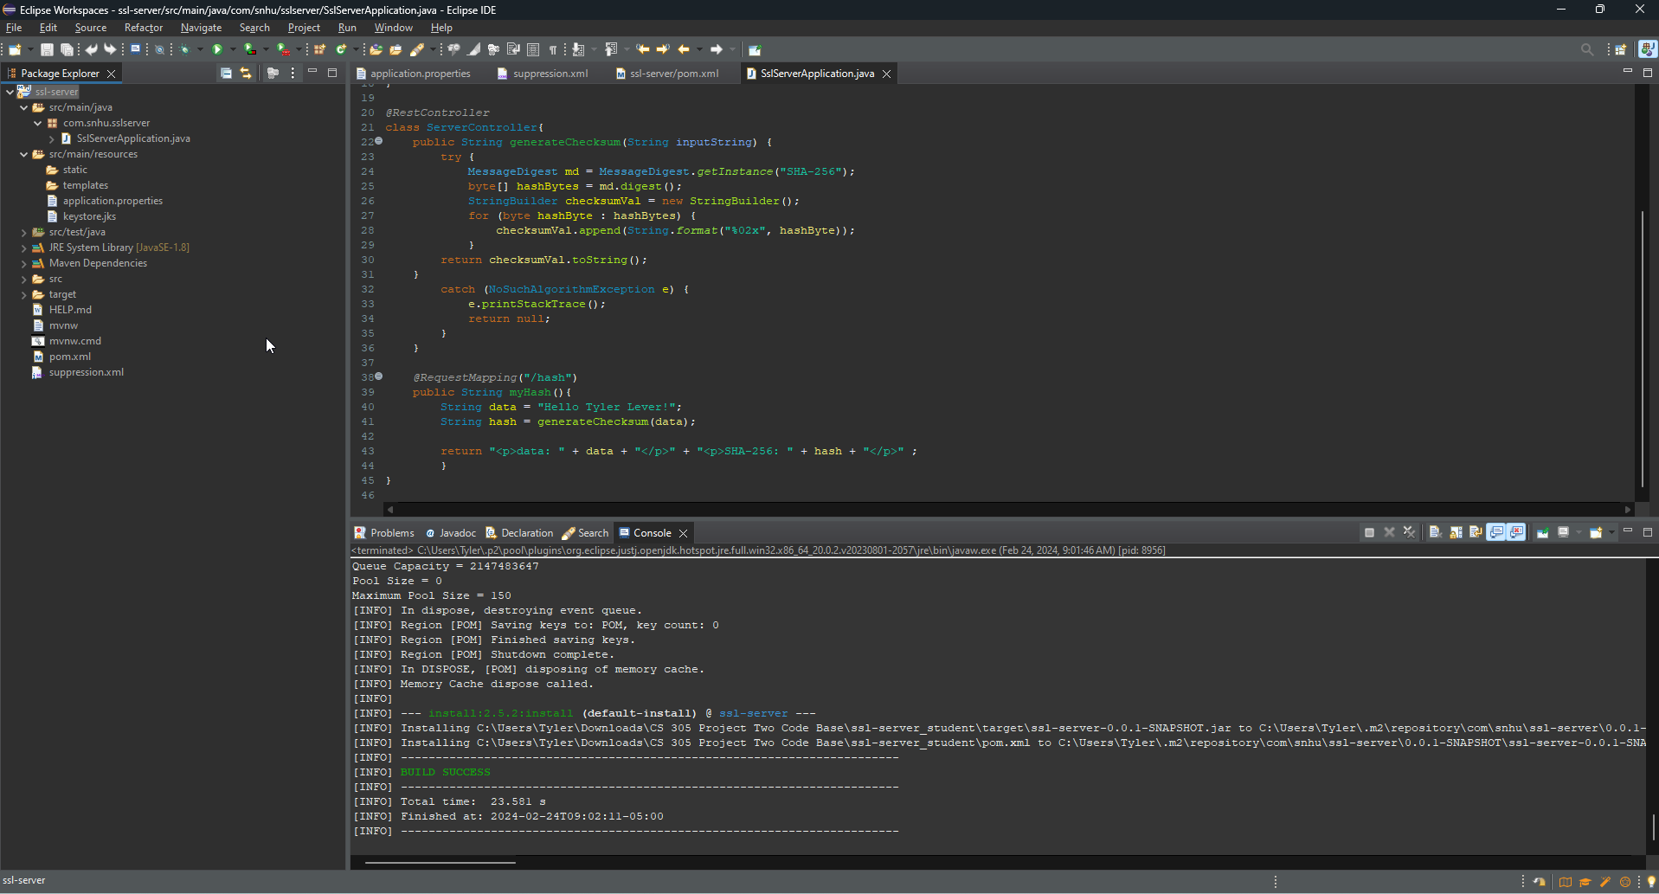

Summary

Input Validation: There is no input for this application. I started expanding the application to find a need for input validation, but that caused feature creep and I started to go out of the scope of the program.

API’s: there is no API use in this program.

Cryptography: The data that needs to be transfer would be sent in a string called “data”. “data” is then sent through an SHA-256 checksum to generate a string.

Client / Server: An HTTPS is being used to help secure communication between client and server. The checksum used from the cryptography could also be used to verify communication is not being intercepted and changed.

Code Error: A try block is used for error handling.

Code Quality: Generally accepted coding practices are used.

Encapsulation: The SHA-256 checksum is separated from the data. This makes it harder for a breach to hide itself from the checksum.

I started to separate “Hello “ and “Tyler Lever” to add more encapsulation and input validation. However, this started to lead to feature creep and I was working out of the scope of the project. Had the project been to take user input and send it through the checksum, this is the approach I would’ve taken.

Industry Standard Best Practices

SHA-256 was used in the checksum. This is considered an industry standard hash function. The use of HTTPS with a certificate helps ensure connection to the correct server. A big reason for following industry standard best practices is the cumulative experience. I was saw a reddit post a couple of weeks ago, sorry I can’t find it again, where the poster wanted to encrypt data through AES then encrypt it again. There was a great comment in that thread when explaining why AES is secure enough “people with a lot of letters attached to their developed and tested it”. There’s not need to go against the norm when more people, that are also a lot smarter than me, have spent more time building these best practices.

